Entry requirements:
There are no formal entry requirements for Family Learning courses. All Family Learning courses are free to learners.
Impact: Where will the course lead?
This could be other Family Learning courses at your child’s school to help with a variety of subjects or classes at one of our LASALS settings, or local colleges. The Family Learning, Learner Recruitment and Welfare Officer (0116 454 6912) and your tutor can guide you in making choices for your next steps.
If you are unemployed or at risk of redundancy our suite of free employability courses can provide you with the skills, you need to secure future employment.
Summer 2020 Online Learning:
Once you have enrolled you will be allocated to an online group with 8 other parents/carers. You will be given details of how to join our secure Google Classroom and your tutor will email you about starting your course.
LASALS

Course information
Getting Ready for School
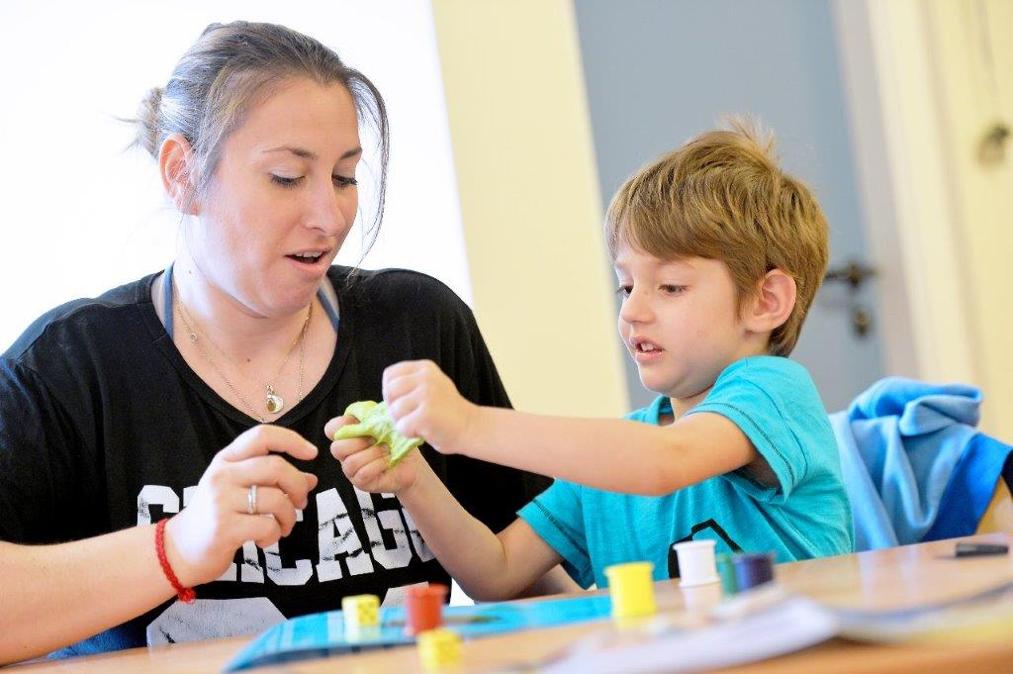

Choosing the right course for you:
This online course has been designed to support you to understand how to help your child be ready for school by exploring how children learn through play. The course is suitable for learners with little experience or knowledge.
The tutor will adapt the online learning activities to suit all abilities and needs after meeting you all in week 1.

Learning Intent – what you will learn about:
This short course will support you to understand:
- The value of using play to support your child’s learning and confidence which will help them settle better when they start school
- How to be more confident supporting your child’s learning across all areas of the foundation stage
- How to make learning fun using games and activities

Understanding the benefits of:

- Using Songs and Rhymes
- Sharing Stories and making a Story Sack
- Early Writing/Mark Making
- Get up and Go – ideas for physical play
- Early Maths games

What to expect:
You are assessed in the online classroom by the tutor and by your own self- assessment of topics. You will be given an online RARPAP/diary form on which you and the tutor will be able to chart your progress each week. Your tutor will give you feedback and suggest ways in which you can improve and help your child’s learning.
You will be given a small number of home-time tasks, linked to helping your child and to support other areas of learning you have identified.
So that you can be successful in completing the course we do require that you try not to miss any sessions – talk to your tutor about individual video catch ups.
Alison Greet, Family Learning Co-ordinator 0116-4541888

