Entry requirements:
There are no formal entry requirements for Family Learning courses. All Family Learning courses are free to learners.
Impact: Where will the course lead?
This could be other Family Learning courses at your child’s school, English classes at one of LASALS settings, other courses at LASALS or local colleges. The Family Learning, Learner Recruitment and Welfare Officer (0116 454 6912) and your tutor can guide you in making choices for your next steps.
If you are unemployed or at risk of redundancy our suite of free employability courses can provide you with the skills, you need to secure future employment.
Summer 2020 Online Learning:
Once you have enrolled you will be allocated to an online group with 8 other parents/carers. You will be given details of how to join our secure Google Classroom and your tutor will email you about starting your course.
LASALS

Course information
KUWC English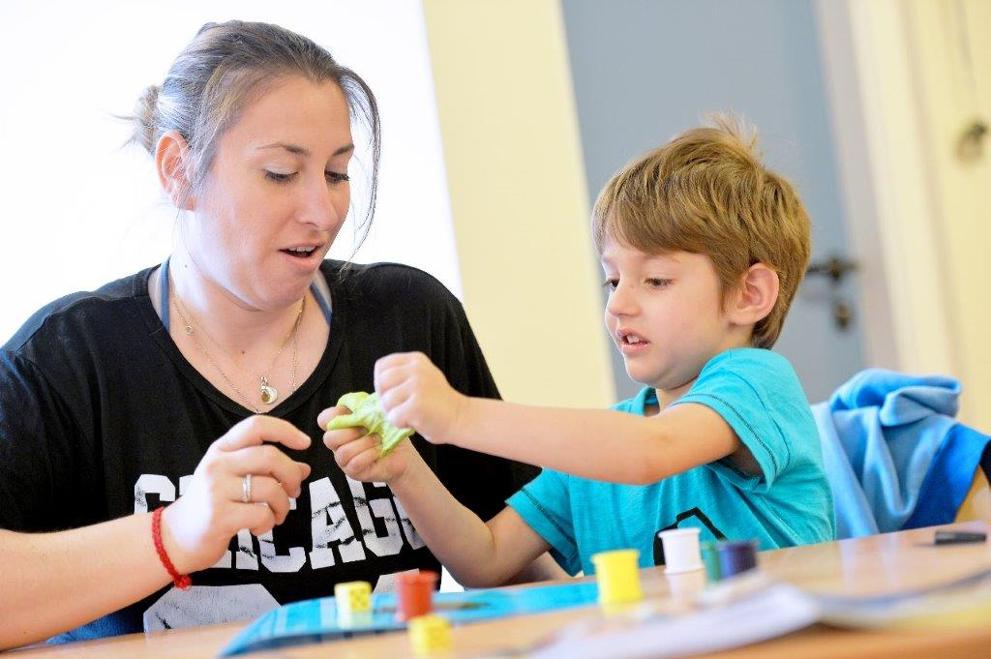

Choosing the right course for you:
This online course has been designed to support you to understand how to help your child at school and to develop your skills in the different ways English is taught.
The tutor will adapt the learning activities to suit all abilities and needs after meeting you all in week 1.

Learning Intent – what you will learn about:
This short online course will support you to understand:
- Different ways to support your child’s English learning using a mix of online resources and practical activities
- How English is taught in schools
- How to be more confident supporting your child in English in different Key Stages/Year groups
- Creating activities and games to support learning English in a fun way
- Helping you to choose the best resources online to support your child alongside the work sent home from school

What to expect:
You are assessed in the online classroom by the tutor and by your own self- assessment of topics. You will be given an online RARPAP/diary form on which you and the tutor will be able to chart your progress each week. Your tutor will give you feedback and suggest ways in which you can improve and help your child’s learning.
You will be given a small number of home-time tasks, linked to helping your child and to support other areas of learning you have identified.
So that you can be successful in completing the course we do require that you try not to miss any sessions – talk to your tutor about individual video catch ups.

Alison Greet, Family Learning Co-ordinator 0116-4541888

