Uplands Infants School – KS1 Geography and History 2020 -2021
Term 1 | Basic | Resources | Provision
Term 1 – Session 1  Geography  Leicester  Drivers:  Diversity  Environment  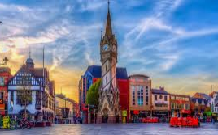  Opportunities | Location:  Where is Leicester?  D: Describe two ways in which Leicester is diverse.  Human Features: Name some famous landmarks in Leicester.  Human Features:  Describe the population.  How far is it from London?  Name areas of Leicester  Where would you find the historic buildings?  What is the name of the stadium where Rugby and Football is played.  D: Where is the Golden mile?  D: What are the main religions in Leicester?  Vocabulary:  city, local, diverse, landmarks, population | Local maps - Leicester  Local maps showing areas  UK map to show locations  Google maps  Photographs of landmarks and the stadium.  Photographs of Golden mile. | What shop would you open on the Golden mile?  Find your house on google maps. Can you find your friends?  Design a landmark to be put in Leicester City Centre  Playdough landmarks  Landmark bingo (Leicester Landmarks)  Large scale local area: Masking tape, tables, small world buildings (See photos)  Can you make? – small world (see photos)
Term 1 – Session 2 –  History  Timelines  Week/month/years | Introduce class timeline which will be ongoing and added to throughout the year.  Possible timelines to be taught:  Parents:  Fictional: e.g. Lion king/ Sleeping beauty etc | Use timelines in class.  Teach concepts of day/week/month/year/decade.
History  King Richard iii  Drivers:  Opp (archaeology)  Local history (living memory and before) | Main Events:  Where was King Richard III born?  What house did King Richard III belong to?  How long did King Richard III reign for?  Where and when was King Richard III’s body found?  Where in Leicester can you find out more information about King Richard III’s life?  Conflict:  Which two houses were fighting for the throne?  What is the name of the last battle King Richard III took part in?  Describe what is meant by the word rebellion.  Who was the War of the Roses between?  Artefacts:  Where was King Richard III found?  What tests were used to confirm that the skeleton was King Richard III?  List some of the places people thought King Richard III should have been buried.  Vocabulary:  Monarch, battle, rebellion, Plantagenet, feud. | Books  Pictures of Leicester (old and new) | Archaeology – search for bones. What could you have found?  Find out when and how other kings and queens died. If Richard was the last King to die in battle how did kings after him die?
Term 1 - Session 3 Geography  London, England  Drivers:  Diversity  Multiculturalism, tourism  Environment  Tourist attractions  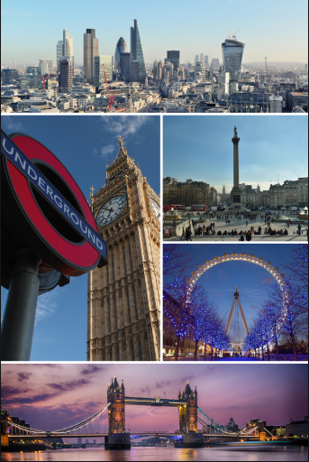 | Location:  Where is London?  Physical Features:  Which river runs through London?  Why was the river important when London was first built?  Human Features:  What is special about the city of London to the UK  Transport - tube  Name famous features of London  Describe the population of London  Stadium in London  D: Describe two ways in which London is diverse.  Vocabulary:  Population, emblem, migrated, tourism, refugees | National maps  Local maps – London  Tube maps  Photographs of landmarks and the stadium.  Photos of River Thames, canary wharf,  Pics showing diversity e.g. posh areas, poor areas (Tower Hamlets). | large scale map making (see photos)  Buckingham Palace:  small world  Transport role play:  buses, tubes, river boats.  Football tuff tray (see photos) & flags for teams. Chn. to make the goals and shirts.  Draw what you think you would see from the London Eye  (aerial sketches)
Term 1 session 4 – History  Great Fire of London  Drivers:  Environment  Opportunities engineering  Wider knowledge of the UK  changes to fire service & infrastructure.  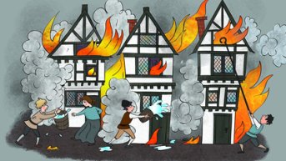 | Main Events:  Describe how the fire started.  How many houses were destroyed?  Which cathedral was destroyed in the  fire?  Name a famous eyewitness to the event.  When did this happen?  What factors played a key part in the  spread of the fire?  Settlements:  Describe what is meant by the word  'congested'.  Describe what is meant by the word  'flammable'.  What material did King Charles II order the  city to be rebuilt in?  Which architect drew the plans to rebuild  St Paul's Cathedral?  Location:  Which country is London the capital city  of?  Use a map to show how quickly and how  far the fire spread.  Artefacts:  What was the name of the writer whose  diaries tell us more about events during the  fire?  Describe what is meant by the word  'extract'.  How can these diaries be used to learn  about the fire?  Vocabulary:  decades, congested, flammable, architects, eyewitness, extract. | Re-counts  Diaries  Maps of then and now  Materials  Blank Maps/squared paper | House/street making  bakery  Chain buckets outside.  bubble painting London skyline (see photos)  Creating fire – playdough  paint  wool  Fire Engines  Kitchen:  biscuits/bread
Term 1 Session 5 – Geography  The United Kingdom  Drivers:  Diversity  Different cultures of each country in the UK.  Multicultural society.  Environment  Landmarks  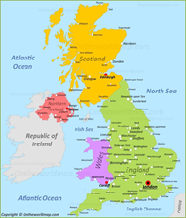 | Location:  List and show on a map of countries that make up Great Britain, United Kingdom, British Isles.  In which ocean is the UK?  Which country is south of UK.  What is an archipelago  What does it mean if the country is described as a union?  What is a monarchy?  What is a democratic government?  Vocabulary:  United, union, monarchy, democratic, government, archipelago | Globe  UK maps  Road maps  Atlases  UK country flags and crests | playdough parts of the UK (see photos)  Design your own archipelago. How many islands will you have? Who will live there? Which ocean will it be in?

Term 2 | Basic | Resources
Term 2 Session 1 – History  Plague: The Black Death  Drivers:  Environment: home & travel  Current Climate  hygiene  evolution of medicine  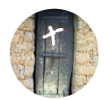 | Main Events:  What other name was the plague known by and why?  When did the plague first reach England?  How many people did the plague kill?  List some facts about the Black Death and put them onto a timeline.  When was the last outbreak in England?  Society:  Who was affected by the plague?  How were people warned that someone had the Black Death?  List some of the ways people tried to help.  How were the victims buried?  Travel & Exploration:  What reasons did people have to travel across Europe in the 1300s?  Name the benefits of travel and exploration.  What role did travel and the movement of people play in the Black Death?  Artefacts:  What kind of historical accounts can we use to tell us about these events?  Whose diary gives us information about the outbreak in London in 1665?  Describe what is meant by the word 'chronicles'.  Vocabulary:  ancient, outbreak, centuries, eyewitness, chronicles, recount | Eye Witness accounts  Diaries  Pepys’ recount  books  Old world maps  Print out of ‘Ring-a-ring-a-roses’ | germ experiment.  design a symbol to keep people out of an area.
Term 2 Session 2 – Geography  Continents & Oceans  Drivers:  Diversity  Different cultures around the world  Environment  Landmarks Opportunities  Travelling the world  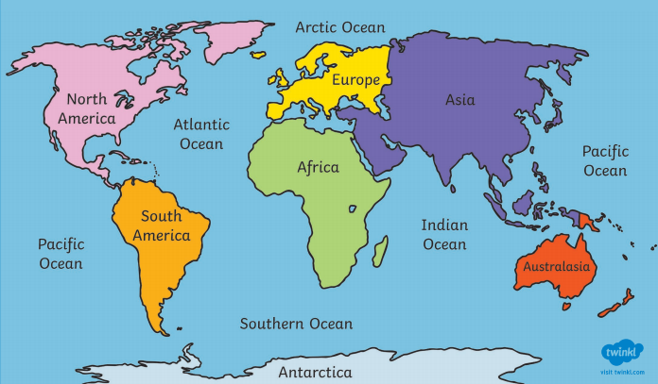 | Location:  Locate and mark on a map the seven continents.  Locate and mark on a map the five oceans.  What are the closest seas to the United Kingdom,  Physical Features:  What is the part of the Earth’s crust that is not submerged by water?  What is a continent?  What does ‘saline’ mean?  What are oceans that are enclosed called?  Human Features:  What is a country?  Which continent is uninhabited?  Vocabulary:  Continent, ocean, saline, species, enclosed, seas, magma, submerged | Globe  UK maps  Road maps  Atlases  UK country flags and crests | Design your own globe on a balloon.  Make a map showing all the continents (Art area, D&T, Small world, tuft tray)
Term 2 Session 3 – History  Marie Curie  Drivers:  Opportunities – Female Scientist  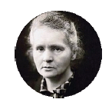 | Main Events:  List the main achievements of Marie Curie's life and add them to a timeline.  When did Marie Curie win her second  Nobel Prize?  Who was Marie Curie's husband and when did he die?  Describe what is meant by the word 'influential'  Location:  Where was Marie Curie born?  Where was Marie Curie educated?  What other events were taking place in  these countries during Marie Curie's lifetime?  Society:  Why did Marie Curie have to travel to another country to study?  Describe her legacy.  Conflict:  What did Marie Curie invent that helped soldiers during the First World War?  Who worked with Marie Curie on the front line in the First World War?  Artefacts:  How did Marie Curie share her work with other scientists?  Why do Marie Curie's diaries have to be handled with care?  Vocabulary:  influential, radioactivity, achievements, legacy, diagnosis | Diaries  Notebooks  Letters  Maps of Europe  Information on Key impact Marie Curie had on First World War. Basic Facts about the First World War | x-ray pics (ipad)  create bones (tuff spots)
Term 2 Session 4 – Geography  Mapping the World  Drivers:  Environment  Our place with in the world.  Neighbouring countries  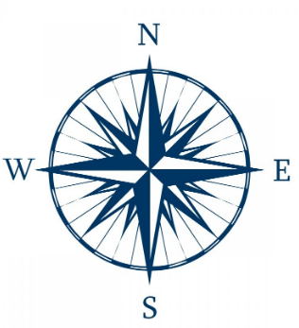 | Techniques:  What is a globe?  What is a map?  What is an atlas?  What is a satellite image?  Label a compass rose showing north, south, east and west.  Label an image of Earth showing north, south, east and west.  Label an image of Earth showing: North Pole, South Pole, axis, equator, northern hemisphere and southern hemisphere.  Vocabulary:  Globe, maps, atlases, satellites, direction, north, south east, west, axis, hemisphere, equator, north pole, south pole. | Globes  Maps  Atlases  Compasses  Satellite images | Design/ make a compass that shows the position of the 4 directions. ( art, D&T, STEM, Construction, ipads)  Label the equator, northern hemisphere and southern hemisphere on different sized spherical objects
Term 2 Session 5 – History  Tim Berners Lee  Drivers:  Opportunities  Children’s interest in technology  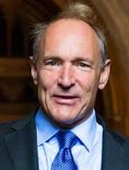 | Main events:  Describe what is meant by the word information?  List the significant achievements in TBL’s life.  What is the difference between the internet and the world wide web?  Where did TBL go to university?  Society:  List the main changes WWW has made to society  What has the WWW helped us to do?  Artefacts:  Do artefacts always have to be old?  What primary and secondary sources could you use to find out about Tim Berners Lee?  How could you use the www to find out about his achievements?  Culture & pastimes  What are web pages used to share?  List many things as you can that…..  What is Berners Lee legacy?  Vocabulary:  world wide web, internet, communication, influential, significant. | Can that have been made easier because of the invention of www  old technology  Videos of people accessing the WWW when first created | old technology – explore  can you design a new piece of technology and make a prototype (construction/small/ world)

Term 3 | Basic | Resources
Term 3 Session 1 – Geography  Climate  Drivers:  Diversity  Different traditional clothing according to climate around the world  Environment  Different climates compared to UK  Opportunities  Geology  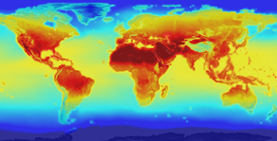 | Location:  Locate and label where polar climates are found.  Locate and label where equatorial climates are found.  Physical features:  Define the word climate.  Define the word weather.  Describe the physical features of polar climates.  Describe the physical features of equatorial climates.  What is another name for equatorial climates?  Describe the physical features of desert climates.  How humans had an impact on the environment and climate change?  Vocabulary:  Temperatures, climate, weather, polar, equatorial, tropical, extremely, vast, thrive | Globes  Maps  Maps with temperature zones  Weather chart  Books on different climates | Design school uniforms appropriate for different climates. (polar, equatorial and desert)  Small world- Sort animals into climate appropriate habitats.
Term 3 Session 2 – History  Queen Elizabeth II  Drivers:  Environment – Commonwealth  Current reigning monarch.  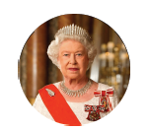 | Main Events:  When and where was Queen Elizabeth II born?  List Queen Elizabeth II's official titles.  List some important dates in Queen Elizabeth II's life. Add these to a timeline.  Name Queen Elizabeth II's children.  Describe what is meant by the word  'monarch'.  Society:  Describe some of the activities that Queen Elizabeth II takes part in.  Who does the Queen welcome to Great Britain?  What is the Commonwealth?  Describe what is meant by the word 'nation'.  Beliefs:  Which church is Queen Elizabeth II the Supreme Governor of?  Which monarch was the first leader of the Church of England?  Culture and Pastimes:  Which Queen started many of the traditions that Queen Elizabeth II follows?  When did Queen Elizabeth II give her first Christmas message on television?  Vocabulary:  monarch, coronation, decade, government, political, tradition. | Books  Videos of the Queen Speech  Letters from the Queen  Videos of the Coronation  Family portraits released by the Royal Household  Map of the British Commonwealth from different periods. | role play – castle  make a palace (art/construction/small world)
Term 3 Session 3 – Geography  Weather  Drivers:  Opportunities  Meteorology  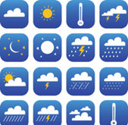 | Physical Processes:  Observe and record the weather for a whole school year.  Define the word weather.  Where does the physical process of weather take place?  What is the atmosphere?  Define the word climate?  What is a physical process?  Techniques:  Label common weather symbols  Label common extreme weather symbols.  Vocabulary:  Frequently, represented, symbols, physical process, atmosphere, technique | Weather chart  Weather station  Rain maker  Maps  Green screen | Keep a weather diary for the week using the weather symbols using any medium to showcase  Record your own weather forecast on a green screen  Measure rain water for a week at home and at school. Is it the same amount?
Term 3 Session 4 – History  Queen Victoria  Drivers:  Diversity  Cross culture marriage.  Compare to today’s Queen.  Links to the Commonwealth  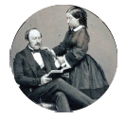 | Main Events:  What does the word 'monarch' mean?  Who was on the throne before Queen Victoria?  When was Queen Victoria's reign?  When was the Victoria and Albert Museum opened?  How did Prince Albert's death in 1861 affect Queen Victoria?  What was Queen Victoria's legacy?  Society:  How did Queen Victoria change the role of the monarchy?  Describe what the word 'politics' means.  List some of the events Queen Victoria attended.  Name the countries that made up the British Empire when Queen Victoria was on the throne.  What items were traded around the British Empire?  Artefacts:  How many objects are there in the Victoria and Albert Museum?  List the reasons why the Victoria and Albert Museum was opened.  Describe the Victoria and Albert Museum and its significance.  Culture and Pastimes:  List some of the events that take place in modern times at the Royal Albert Hall.  Describe what is meant by the word 'memorial'.  Vocabulary:  monarch, monarchy, legacy, politics, memorial, matriarch, British Empire, trade, slave. | V&A Musuem – virtual tours, information, pictures from time of opening and now.  Royal Albert Hall - virtual tours, recorded concerts, information, pictures from time of opening and now.  Letters  Photos  Proms programmes | role play – palace  what would you put into the V&A and why?  ships – trade  what tradition would you start if you were king or queen?
Term 3 Session 5 – Geography  India  Drivers:  Diversity  Learning about a country native to the majority of pupils in our school  Environment  Physical features different to the UK  Opportunities  Many children in the school have visited India but not seen past their relative’s home.  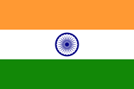 | Location:  What Continent is India located in?  Describe the location of India.  What is the Commonwealth?  What is India’s capital city?  Which Ocean is on India’s peninsular?  Physical Features  Which mountain range can be found in the north east of India?  What is Thar?  What is the longest river in India?  Name the country that shares the Thar desert as a border.  Human Features:  How many states are there in India?  Locate and label the main cities in India?  What is the capital city of India?  What is the population of India?  Which is the main religion in India? | Globes  World Maps  Maps of India  Atlases  Books- India  Books- mountains  Books- Desert  India flag  Names of the 28 states  Photos of urban and rural environments  Sand | Display the Thar desert showing how it creates a border between India and Pakistan. (Any medium)  Make the Himalayan mountain range with Playdough.  Make the Indian flag (From any medium)  On a map, locate and label the 10 cities  Make a tiger or peacock (From any medium)
Term 3 Session 6 – History  Moon Landing  Drivers:  Opportunities  Children’s interest  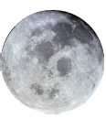 | Main Events:  Describe what is meant by the word 'astronaut'.  How many astronauts were on Apollo  11?  When did the Moon landing happen?  List the main events in the Moon landing.  What was the name of the landing module?  What did Neil Armstrong say when he stepped on the Moon for the first time?  Location:  Find and label the USA on a map.  Where is the Kennedy Space Centre?  What is the Soviet Union called now?  Travel and Exploration:  What was the name of the mission to get to the Moon?  Describe what is meant by the word 'exploration'.  How have we benefited from space exploration?  Conflict:  Which country was the first to send a man into space?  Which countries were in the space race?  Describe what is meant by the word 'rivals'.  Vocabulary:  lunar, achievement, exploration, rivals, orbit. | Maps of the world indicating areas that were involved in the moon landing.  Diaries  Videos from the Apollo 11 mission  Photos of the module and ship  Solar System model  Interviews with key people in the space race. | make the moon/space rockets.  Draw what you think the world would like from space.  design a space suit to keep you safe  role play – astronauts  What planet would you like to explore next?

Provision photos:
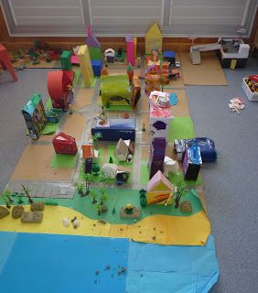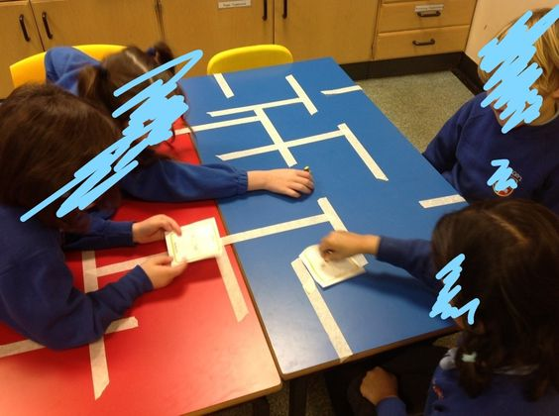 Large scale maps
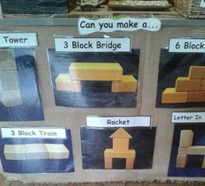 can you make?
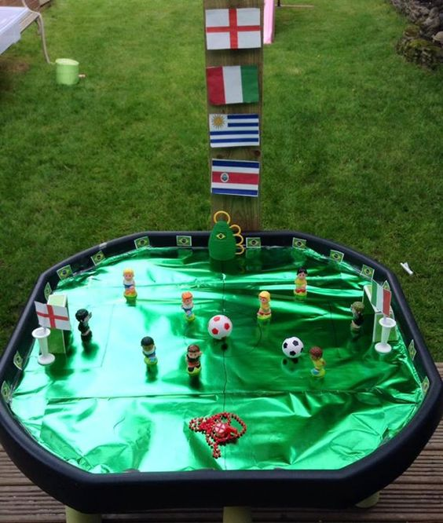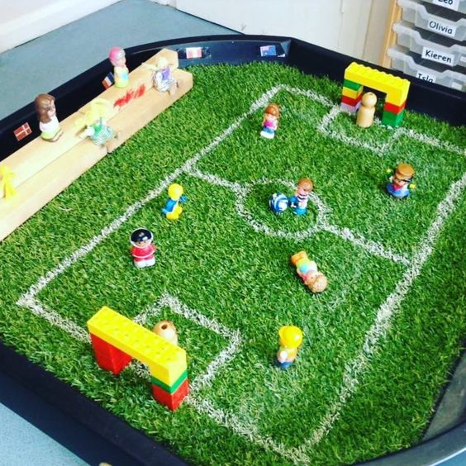 Football tuff tray
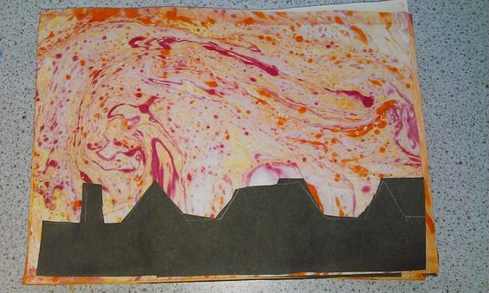 bubble painting
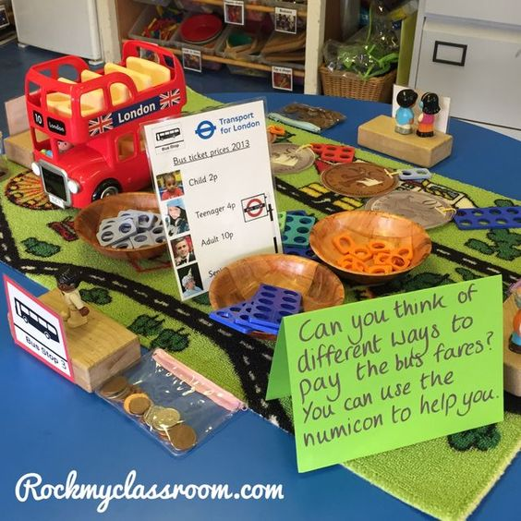transport role play
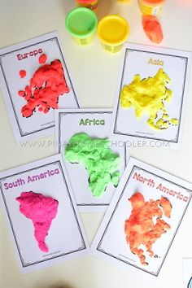 playdough parts of…

