All staff are fully trained in all of the areas within KTC. Training is repeated each year for new staff or for refresher training. There is a KTC lead in school and all SMT are also trained in monitoring KTC. There is expertise within school for practitioners to observe one another and can also visit other KTC schools to observe good practise. We have a link school- Shenton Primary that also provides additional support and external feedback. 2019/2020 Ann Smallberger has worked with our school to adapt timetabling and improve teaching. KTC videos are accessible online for further CPD.

Some weaker readers require additional teaching, this could include:

An additional session of phonics/shared/guided reading

Ph 2 catch up intervention

Applying long vowel intervention

EAL Intervention Group

Oral blending and segmenting intervention

Early Word Intervention- where phonics is not working

Children new to Reception have an intense 6 weeks of PH1 phonics on entry

Monitoring is carried out through:

Observations Team Teaching

Learning Walks External specialists

Drop In

Training and videos

Moderation

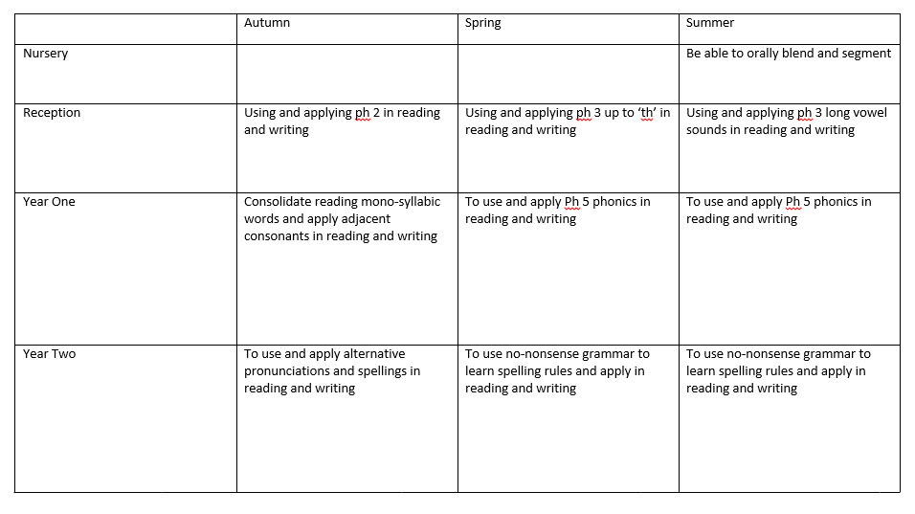

All Children have at least:

Phonics

1x20 min session daily with a re-cap session

Shared Read

3x20 min sessions weekly EY’s, 2xYr 1, 1x session Y2

Guided Reading

1 x session weekly Rec-Y2

Shared/Guided Write

2x shared writing/ 1x guided writing session weekly Rec

1xshared write, 1x guided write- KS1

KTC

All assessments for GPC and sight word reading are carried out at regular intervals in accordance with the scheme and carefully analysed. Revision lessons are planned to then fill these gaps. Guided reading levels directly correspond to the child’s current reading capability.

KTC is a quality first approach to teaching phonics, reading and writing in Early Years and KS1.

KTC phonics is based on Letters and Sounds with a comprehensive lesson plan that teaches children to hear, read, write and apply phonemes in reading and writing. The approach gives teachers the structure of lessons, resources and assessments.