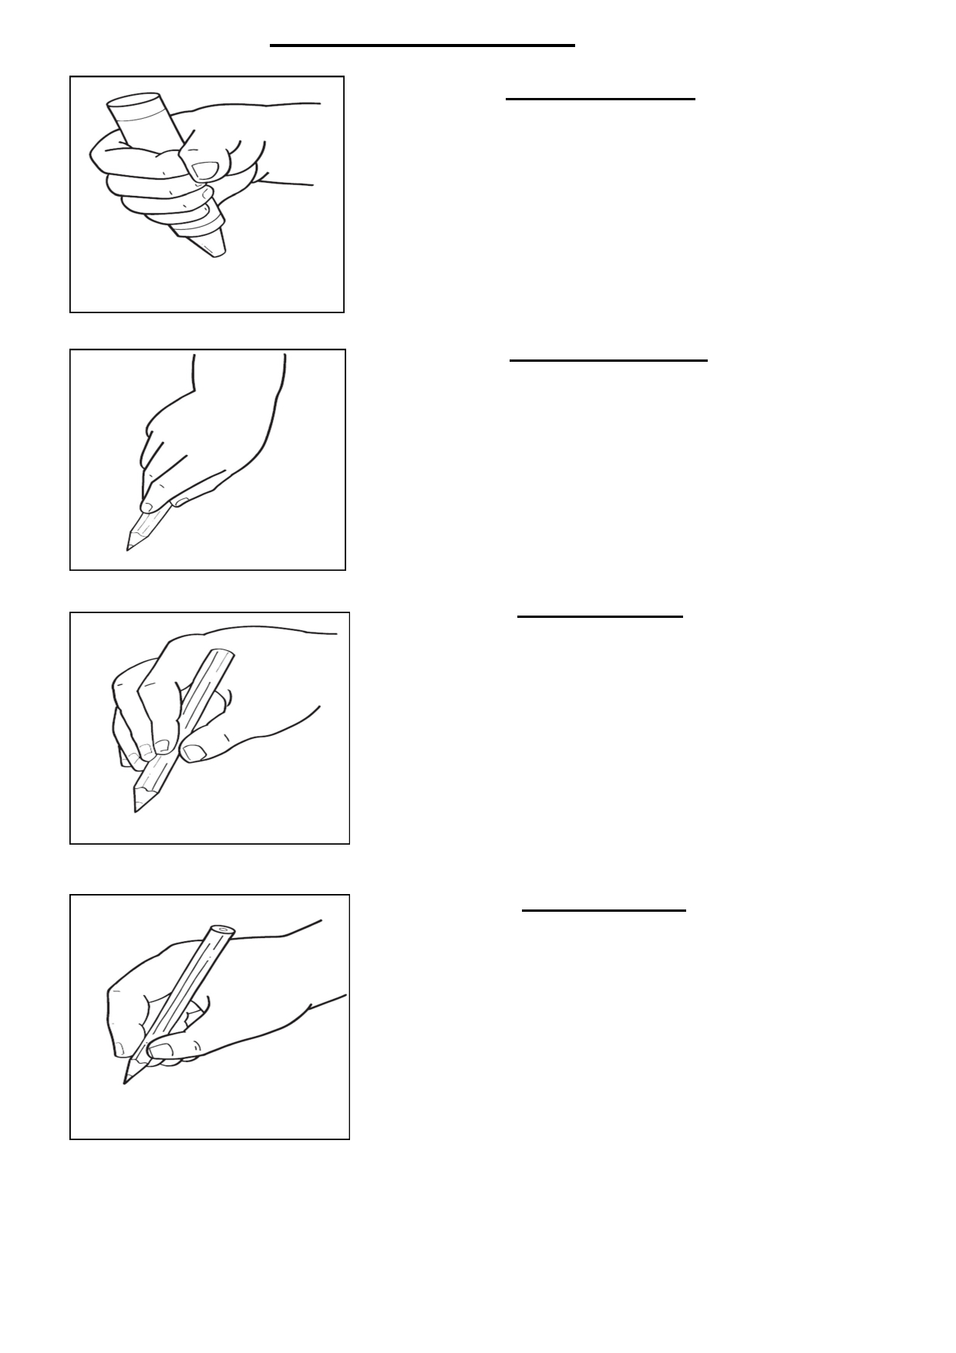Progression of Grips

Palmer supinate grip
Most children start mark making by using
the palm grip. The implement is held in
the palm of the hand and the fingers curl
around it to hold it in place.
The movement is mainly controlled
through the shoulder and wrist joints
(gross motor) and children will typically
make vertical, horizontal and round
marks.

Digital pronate grasp
The next grip is often the digital
pronate grasp, although not all children
use this. The mark making implement in
controlled by one digit, usually the
index finger, and held in place by the
thumb. To use this grasp the child
needs to pivot from the wrist to get to
the paper. Movement is limited and
mark making is similar to that of the
palm grip.

Static tripod grip
The next stage is often the static
tripod grip which is usually favoured
by boys. The pencil is pushed right to
the end of the fingers.
The movement is controlled by the
little finger and clamped in place by
the thumb although all the digits are
in contact with the pencil. With this
grip it is difficult for the child to
see the marks they are making which
hinders correct letter formation.

Triangulation grip
The triangulation grip is where the
pencil is held between the
forefinger and the thumb and
supported from behind by the
middle finger. Ideally only these
three digits control the movement
of the pencil. The movement (fine
motor) is controlled by the joints of
the fingers and thumb and allows
for maximum range of movement
and flexibility. This is the grip to aim for.

